- The external Inspection procedures must be performed by technicians after finished maintenance activities. Any discrepancy detected, correct if feasible and inform CCM department as soon as possible.
ITEM | DESCRIPCIÓN  DESCRIPTION |  |  | TÉCNICO  TECH
Instruction: Mark the box if the condition was OK
1 | Perform the walk-around to the aircraft, put special attention to listed below:  - Aircraft exterior for cracks, dents o any damage to put risk the airwrokthy  - Brake assembly for general condition  - MLG Tires for wear and general condition. Visual Inspection MGL Wheel assemblies  - NLG Tires for wear and general condition. Visual Inspection NGL Wheel assemblies  - Visually check underwing Surfaces, tank access panels, dump valves and drain valves for absence of fuel leakage  - Pitot/Static ports for absence of foreign matter  - Trailing static dischargers for correctly installed and damage  - Perform visual inspection of the Radome boot for security and condition |  |  | 
2 | Perform operational test of all exterior lights: Navegation, position, anti-collision, taxi, landing and wing inspection |  |  | 
3 | Be sure that those documents are on board: Airworthiness certificate, radio station license and stock logbooks (not in use):  Maintenance blocks (qty) _____ Operations blocks (qty) _____  Flight attendent blocks (qty) _____ Deferred blocks (qty) _____ |  |  | 
4 | Inspect cockpit seats for correct condition of vertical adjustment, lumbar support, armrest, recline function, lateral adjustment |  |  | 
5 | Inspect passenger seats and safety belts to identify any discrepancy (recline, mechanism, armrest, torching, missing or correct belt attachment to the track) |  |  | 
6 | Inspect (GV) emergency equipment (First Aid Kit, fire extinguisher bottle, portable oxygen bottle, PBE), for condition and validation. |  |  | 
7 | Inspect the oxygen pressure, confirm 1100 psi at 21°C (70°F) for flight crew made up of pilot and copilot 1500 psi at 21°C (70°F) for flight crew made up of pilot, copilot, and observer |  |  | 
8 | Perform APU data readings for total times, total cycles, and record in accordance with MRBR TASK 49-74-01-2  S/N: ____________________ TOTALS HOURS: ____________ TOTALS CYCLES: ____________
9 | CHECK OIL LEVELS :  Engine oil level (only use MIL-PRF-23699 STD, (TURBO OIL 2380)) must reach the one-quarter mark. In case of adding oil in one or both motors, after refilling oil, make sure that the oil filler cap is properly closed. It is necessary to record the quantity in the maintenance logbook.  (Ref: MM RR 12-10-79-801, AMM 12-12-01-600-801-01) | 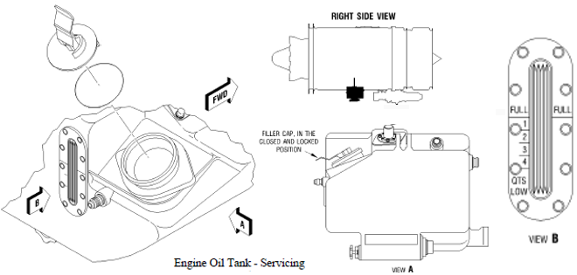 |  |  | 
9 | APU oil level:  (ONLY USE MIL-PRF-23699 STD, (TURBO OIL 2380)). Do not refill oil above the "Full" mark. After refilling oil, make sure that the oil filler cap is properly closed.  (Ref: EM HAMILTON 49-00-00-1101, AMM 12-12-02-03) |  | 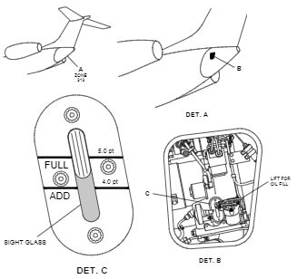 |  | 
9 | Level of hydraulic fluid:  (ONLY USE SAE AS 1241, Type IV (SKYDROL 500B-4))  Make sure that the indicated level is between the 4.5 and 5.5 liters mark. The shaded region corresponds to the range of dispatchable. If it is below the indicated mark, recharge the system until it is in the correct range. The low level in the reservoir can be a sign of a leak in the system.  (Ref : AMM 12-13-01-03)  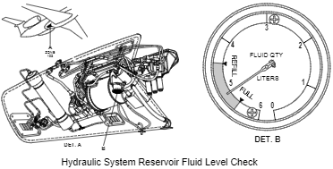 |  |  |  | 

Acciones Correctivas: / Corrective Actions:
Matrícula / Registration:
Nombre del Técnico: Technician Name:  | H-H: Man Hour:  | Licencia: License No.  | Firma: Signature: 
Estación: Airport:  |  | Fecha: Date: 

